Title:
Decision Tree for Student Performance Prediction

Abstract:
This paper explains the use of Decision Tree algorithm in machine learning. It is used for classification and prediction tasks. The algorithm splits data into smaller parts based on conditions. It is simple, easy to understand and useful for predicting student performance.

Introduction:
Machine Learning helps in predicting outcomes using data. Decision Tree is a supervised learning algorithm used for classification and prediction. It creates a tree structure with root node, internal nodes and leaf nodes to make decisions.

Methodology:
Data is collected for student performance.
The data is divided into training and testing sets.
Decision Tree algorithm is applied.
The model predicts whether the student will pass or fail.

Results:
The model predicts student performance based on given input.
It produces fast and accurate results.

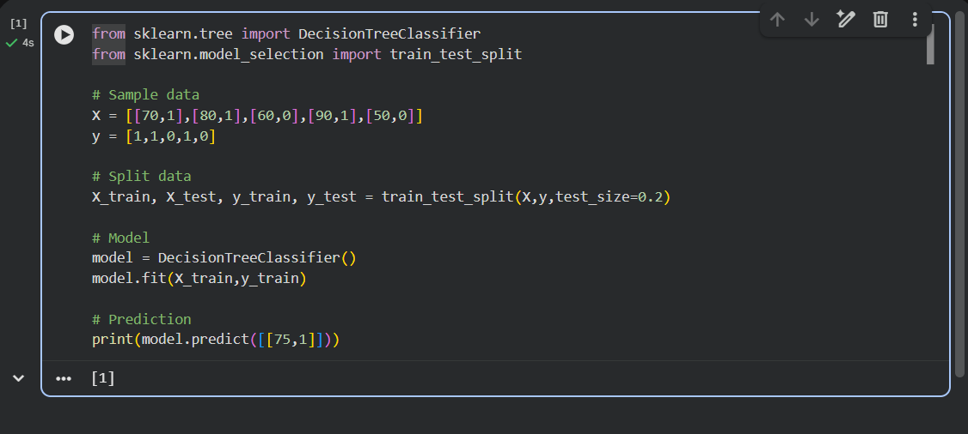Output of Decision Tree Model (Prediction = 1)

Extension:
The performance of the Decision Tree can be improved by using pruning techniques to reduce overfitting.
It can be combined with Random Forest for better accuracy.
It can be used in real-time student monitoring systems.

Conclusion:
Decision Tree is simple, easy to understand and effective.
It is useful for prediction problems and can be improved further.

References:
A Study on Decision Tree Algorithm for Classification
Scikit-learn Documentation

